

**NAME:**

**Parent Signature:**

12 ATMAM TEST 2

**Section 1: / 34**

**Section 2: / 25**

**Total: / 59**

**%**

Material required/recommended for this test

To be provided by the supervisor

Question/answer booklets for Sections One and Two.

SCSA 12 Formulae Sheet

To be provided by the candidate

Section One:

Standard items: pens, pencils, pencil sharpener, highlighter, eraser, ruler

Special materials: drawing instruments, templates, no notes, formula sheet

Section Two:

Standard items: pens, pencils, pencil sharpener, highlighter, eraser, ruler

Special materials: drawing instruments, templates, notes on a maximum of one unfolded sheet of A4 paper, double sided, up to three approved calculators, CAS, graphics, or scientific.

Important note to candidates

No other items may be taken into the test room. It is your responsibility to ensure that you do not have any unauthorised notes or other items of a non-personal nature in the test room. If you have any unauthorised material with you, hand it to the teacher before reading any further.

STRUCTURE OF SECTION 1

|  |  |  |  |  |  |
| --- | --- | --- | --- | --- | --- |
| Section | Number  of  questions  available | Number  of  questions  to  be  answered | Working  time  (minutes) | Marks  available | Percentage  of Test |
| Section  One:  Calculator-free | 5 | 5 | 35 | 34 |  |
| Section  Two:  Calculator-assumed |  |  |  |  |  |
| Total | | | | |  |

1. Determine each of the following leaving your answers with positive indices. [10 marks: 2, 3, 2, 3]

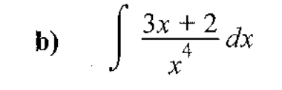

1. [5 marks: 2, 3]

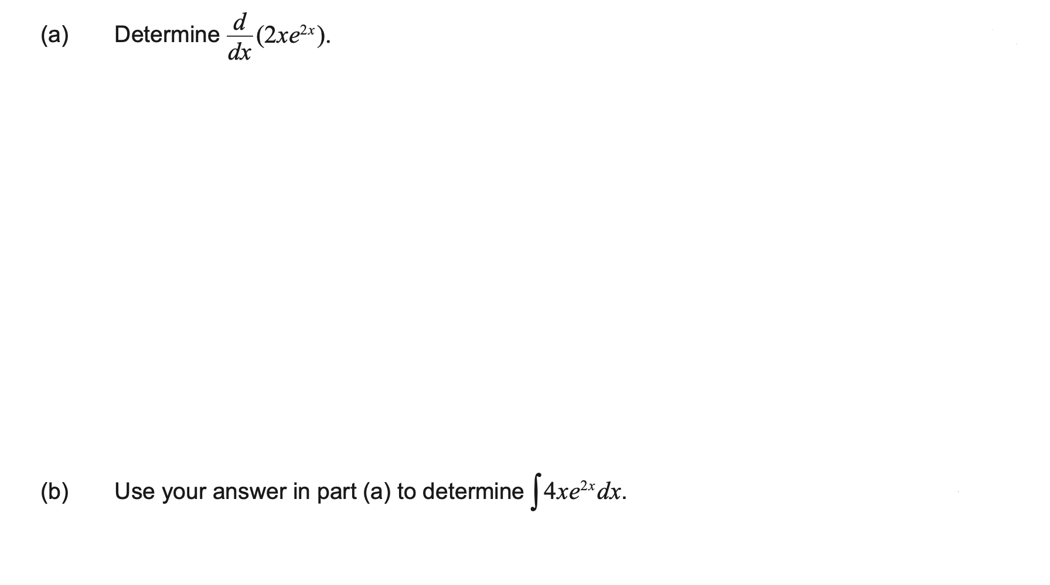

1. [8 marks:2, 6]

A curve has first derivative $\begin{matrix}dy \\ \overline{dx}\end{matrix}=6x(x-2)$ and passes through the point $P(-1, -8)$.

(a) Determine the value(s) of $x$ for which $\begin{matrix}d^{2}y \\ \overline{dx^{2}}\end{matrix}=0$.

(b) Sketch the curve on the axes below, clearly indicating the location of all axes intercepts, stationary points and points of inflection.

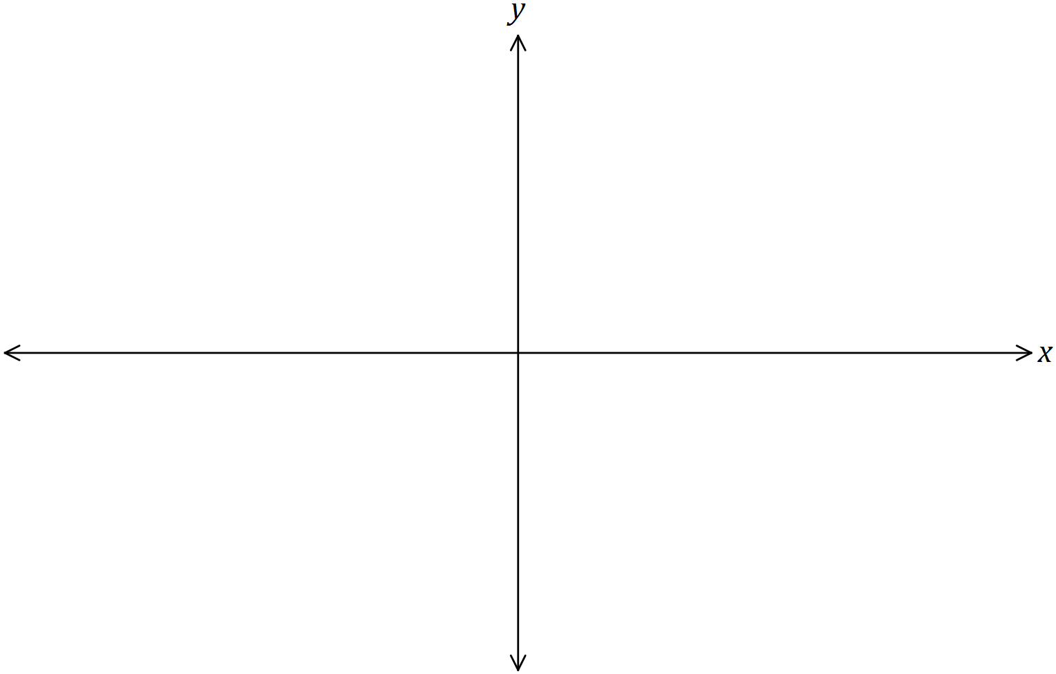

4. [4 marks:3, 1]

Given 

a) Determine the value of *f* “(-1)

b) Describe the concavity of the curve at this point.

5. [7 marks: 2, 5]

An Isosceles triangle ΔPQR is inscribed inside a circle of fixed radius r and centre O, let θ be defined as in the diagram below.

1. Show that the area A of the triangle ΔPQR is given by A = r2sinθ(1 + cosθ)

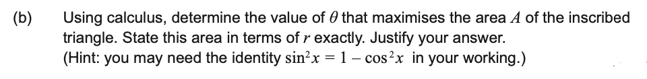



**NAME:**

**Section 2: / 25**

12 ATMAM TEST 2

CALCULATOR ASSUMED

Show all your working clearly. Your working should be in sufficient detail to allow your answers to be checked readily and for marks to be awarded for reasoning. Incorrect answers given without supporting reasoning cannot be allocated any marks. For any question or part question worth more than two marks, valid working or justification is required to receive full marks. If you repeat any question, ensure that you cancel the answer you do not wish to have marked.

STRUCTURE OF SECTION 2

|  |  |  |  |  |  |
| --- | --- | --- | --- | --- | --- |
| Section | Number  of  questions  available | Number  of  questions  to  be  answered | Working  time  (minutes) | Marks  available | Percentage  of Test |
| Section  One:  Calculator-free |  |  |  |  |  |
| Section  Two:  Calculator-assumed | 4 | 4 | 25 | 25 |  |
| Total | | | | |  |

6. [6 marks:1, 1, 1, 3]

The table below contains information about the sign of ,  and  at six points on the graph of the continuous function .

Apart from those in the table, there are no other points where ,  or  are equal to zero.

|  |  |  |  |  |  |  |
| --- | --- | --- | --- | --- | --- | --- |
|  | -3 | -1 | 0 | 2 | 3 | 4 |
|  | - | 0 | + | + | 0 | - |
|  | + | 0 | + | 0 | - | - |
|  | - | 0 | + | - | - | - |

a) Describe the nature of the graph when 

b) At what value(s) of  is  increasing at an increasing rate?

c) Describe the nature of the graph when .

d) Sketch the function on the axes below.



7. [6 marks:1, 5]

A closed box is constructed with a square base. Exactly 10 square metres of material is to be used in the construction of the box, without wastage.

a) Show that the amount of material used is equivalent to: 

b) By using calculus, determine the maximum volume of the box and state the dimensions required to achieve this maximum.

8. [6 marks]

A popcorn container of capacity $500$ mL is made from paper and has the shape of an open inverted cone of radius $r$ and height $h$.

Determine the least area of paper required to make the container.

9. [7marks: 1, 3, 3]

The rate of change of displacement of a particle moving in a straight line at any time $t$ seconds is given by

$$\frac{dx}{dt}=3+{2e}^{0.1t} \text{cm/s}.$$

Initially, when $t=0$, the particle is at $A$, a fixed point on the line.

(a) Calculate the initial velocity of the particle.

(b) Determine the distance of the particle from $A$ after $20 \text{s}$.

(c) Determine when the acceleration of the particle is $7 {\text{cm/s}}^{2}$.